# (working title) Technical paper ISH analysis

Samme Vreysen, Marie-Eve Laramée, Lutgarde Arckens

Laboratory of Neuroplasticity and Neuroproteomics, KU Leuven, Naamsestraat 59, 3000, Leuven, Belgium

e-mail: [lut.arckens@bio.kuleuven.be](mailto:lut.arckens@bio.kuleuven.be), telephone: +32 16 32 39 51, fax: +32 16 32 39 02

## Abstract (150-250 words)

## Keywords (4-6)

## Introduction

ISH

Mapping: elastix (Klein 2010), 3D reconstruction multi-stain and multimodal analysis (Magee 2015), landmark free mapping (Arganda-Carreras 2010)

grayscale rescaling using histogram rescaling (Chang 2015),

In this study we provide a method to register intensity based images of serial sections, to segment the area of interest following the curvature, project the data to a horizontal plane and define the statistical differences between different conditions.

## Material and Methods

We created a workflow from image registration to statistical comparison of different conditions written in Matlab (Matlab 2015a, The MathWorks Inc., Natick, MA, USA). Serving as biological example data we applied the workflow on data from *in situ* hybridization for *zif268* on adult (P120) monocular enucleated (ME) C57Bl/6J mice having different post enucleation survival times. In this way we can visualize the early visually driven recovery followed by multimodal plasticity in the entire primary visual cortex and extrastriate cortices (Van Brussel et al. 2011; Nys et al. 2014).

### Animals

C57Bl/6J mice of either sex (N = X) were obtained from Janvier Labs (Le Genest-St-Isle, France) and housed under standard laboratory conditions (i.e., standard cages with nesting material) under an 11/13-hour dark/light cycle with food and water available ad libitum. All experiments were approved by the ethical research committee of the KU Leuven and were in accordance with the Declaration of Helsinki. Every possible effort was made to minimize animal suffering and to reduce the number of animals

ME was performed in adult (120 days old) C57Bl/6J mice. We surgically removed the right eye as previously described in depth (Aerts et al. 2014a). Briefly, the animals were anesthetized with a mixture of ketamine hydrochloride (75 mg/ml, todo) and medetomidine hydrochloride (1 mg/kg, todo) in saline (i.p.) and the eyelids were disinfected with 70% ethanol. A sterile curved forceps was guided behind the eye to clamp the optic nerve. Making circular movements with the hand holding the forceps twists the optic nerve twists and eventually constricts it in two. The animals were administered atipamezol hydrochloride (1 mg/kg, todo) in saline (i.p.) to reverse the anesthesia, Meloxicam (1mg/kg, todo) every 24 hours to relieve pain and eye ointment to prevent dehydration of the cornea.

We applied post enucleation survival times of 3 days and 1, 3, 5 and 7 weeks (3dME and 1, 3, 5 and 7wME) after which we sacrificed the animals using an overdose of sodium pentobarbital (Nembutal; 0.2 ml of 60 mg/ml) followed by cervical dislocation. The brains were quickly removed, flash frozen in 2-methylbutane (Merck) at a temperature of -40°C and stored at -80°C. 25 µm thick coronal sections were cut on a cryostat (todo) and mounted on poly-L-lysine (0.1%) coated glass slides.

### *in situ* hybridization for *zif268*

We performed *in situ* hybridization for *zif268* as described before (Van Brussel et al. 2009; Van Brussel et al. 2011; Nys et al. 2014; Aerts et al. 2014b; Smolders et al. 2015). A series of coronal sections between Bregma levels -2.0 and -4.4 mm were selected to span the striate and extrastriate area. We labeled the 3’-end of the mouse-specific synthetic oligonucleotide probe (5’-ccgttgctcagcagcatcatctcctccagyttrgggtagttgtcc-3’, Eurogentec, Seraing, Belgium) with [33P]dATP using terminal deoxynucleotidyl transferase (Invitrogen, Paisley, UK). Unincorporated nucleotides were separated from the labelled probe with mini- Quick SpinTM Oligo Columns (Roche Diagnostics, Brussels, Belgium). The radioactively labelled probe was added to a hybridization cocktail [50% (vol/vol) formamide, 49 standard saline sodium citrate buffer, 1 9 Denhardt’s solution, 10% (wt/vol) dextran sulphate, 100 lg/mL herring sperm DNA, 250 lg/mL tRNA, 60 mM dithiothreitol, 1% (wt/vol) N-lauroyl sarcosine, 20 mM NaHPO4, pH 7.4] and applied to the cryostat sections (106 c.p.m. per section) for an overnight incubation at 37 °C in a humid chamber. The following day, sections were rinsed in 1x standard saline sodium citrate buffer at 42 °C, dehydrated, air-dried and exposed to an autoradiographic film (Biomax MR, Kodak). Films for *zif268* were developed in Kodak D19 developing solution after 6 days. Fixation was performed in Rapid fixer (Ilford Hypam, Kodak). Autoradiographic images from the sections were scanned at 1200 d.p.i. (CanoScan LIDE 600F, Canon).

### Histological borders visual areas

All sections were counterstainded with 1% cresyl violet (Fluka Chemical; Sigma-Aldrich) according to standard protocols. Cresyl violet stainings provide sufficient information to delineate the different visual areas, including primary visual cortex (V1), lateral extrastriate cortex (V2L), medial extrastriate cortex (V2M) and rostromedial areas (RM) as described in detail previously (Van der Gucht et al. 2007; Van Brussel et al. 2009; Van Brussel et al. 2011; Nys et al. 2014; Smolders et al. 2015; Nys et al. 2015) and comparisons were made with the stereotaxic mouse brain atlas (Franklin & Paxinos, 2008). The border annotations for each section were superimposed onto the corresponding autoradiographic image (Figure 1a).

### Image processing workflow

#### Slice registration

In general, for each slice we first create meta data consisting of the condition, animal, filename and corresponding Bregma level. Next, we register the region of interest from the grayscale image by delineating the top and bottom edge of the structure and positioning marks (with ) representing the edges of the different zones within the structure. The top and bottom edge is smoothed by projecting the points onto a local regression line based on a weighted orthogonal least squares fit of the points (test_smooth_contours.m, v1.2, 20 Jul 2011, Tolga Birdal, Matlab Central #30793; wols.m, v1.2, 21 Mar 2011 Andrey Sokolov, Matlab Central #28894) We also choose a small rectangular reference region within the slice known to only express background signals and we trace the midline of the coronal slice to project the data in a later stage into a top view.

Next, we divided the top and bottom edge of region in equal parts by interpolating equally spaced points (with ) along their cumulative arc length and project these points back to their original curve (interparc.m, v1.3, 16 Aug 2012, John D'Errico, Matlab Central #34874; Figure 1b). To verify a good segmentation the orthogonal projection of all K points to the X-axis has to change monotonically. In this way each quadrangular segment is confined by the four points . We calculate the mean optical density from the pixels enclosed by this quadrangle normalized by the reference region using the formula and the distance from the midline of the slice to the center between two adjacent points and representing a projection to the horizontal plane using the formula (Figure 1c):

#### General animal model

To reconstruct the region of interest, a general animal spatial model and a mouse specific intensity map is built from all registered slices within a project by applying the following algorithm (Figure 1d):

1. Create a spatial and intensity map for each animal based on the scattered points with corresponding OD values from all N slice per animal.
2. Smooth the position of medial and lateral edge using a weighted moving average with the weights based on the complement of the symmetrically padded relative second differential. Based on the smoothed outline of the region of interest the position of each point and within each slice is recalculated to fit the new outer boundaries by repositioning the midline. If this is impossible because the morphology is too distorted, the new positions of and are inferred from the surrounding slices by interpolation (inpaint_nans.m, v1.1, 13 Aug 2012, John D'Errico, Matlab Central #4551). This smoothing step allows us to remove both histological and registration variations within one animal.
3. Combine the maps of all animals by calculating the average position after smoothing and across all animals using the weighted moving average like in the previous step to remove excessive variations between animals. The resolution of the anterior-posterior axis is defined by the list of unique Bregma levels present in the project across all animals.
4. Smooth the spatial map along the anterior-posterior axis using the weighted moving average on and .
5. Interpolate the spatial map with a grid with 10µm resolution in both axes.

#### Mouse and condition specific maps

We map the intensity maps from each animal onto the spatial map and interpolate this top view map to a resolution of 10µm in both axes . To join the maps from different animals belonging to the same condition, we calculate the mean intensity value across all animals for every pixel , map this intensity map onto the spatial map and interpolate to a resolution of 10µm in both axes to enhance visualization and statistics. The assembly of condition A looks like this:

#### Pseudo statistics

To quantify the differences between two conditions we adapted and implemented the pseudo statistics created by Holmes et al. (1996), well known in fMRI and PET scan analysis, to match the need for a non-parametric testing approach to compare two dimensional images originating from two independent conditions.

We label a (different) number and of animals to be part of condition or condition respectively and build a statistic image based on those labels. For every pixel we calculate the difference image between the two condition specific maps and and variance image and from condition A and B respectively:

Expecting the true error variance to be smooth we apply a convolution to the variance images using a Gaussian kernel of full width at half-maximum (FWHM), resulting in the smoothed variance images and . Now we derive the pseudo statistic image without assuming equal variances:

The principle behind this pseudo statistics is based upon a randomization and permutation test approach. We can assume that if condition is truly not different from condition this labeling is artificial, hence any other combination of labeling the animals into the two conditions would lead to an equally plausible statistic image. In this way, we create the null hypothesis stating that the labeling is arbitrary for every pixel , meaning that the observed statistical image originated from a random labeling of the animals to condition or . We compute for each possible statistic image one single statistic being the minimum value across all pixels (one tailed decrease), the maximum value across all pixels (one tailed increase) or the maximum of the absolute values of all pixels (two tailed difference). The probability of observing a statistic more extreme than a given value is simply the proportion of statistic images with a statistic exceeding that value, allowing us to compute p values for all pixels in the observed statistic image. Assuming a significance level only the 5% most extreme statistics will be significant. Therefore it can been shown that, knowing that there are possible combinations to label the animals, only most extreme discrete p values are significant. Subsequently, the minimum number of animals for each condition is resulting in significant p value.

Power analyis

#### Example data

We provide an application of the workflow based on *in situ* hybridization data for *zif268* from adult mice with different post enucleation survival times. During the slice registration step, we defined two regions of interest: the upper and lower layers of the visual cortex. To achieve this we delineated the top edge of the cortex, the border between granular layer IV and infragranular layer V and the border between infragranular layer VI and the white matter and marked 5 borders representing V2L, V1, V2M and RM. We segmented both upper and lower layers in K=30 segments.

I think we also should add an application using fluorescent pictures like from my efys brains with a probe track or the expression of a vector from the serotype paper? Or even from SC with data from Emiel to show it’s not cortex specific?

## Results

Overview of the different maps for zif: few animal specific examples, all conditions (maybe limiting to supra), statistics

Second application with fluorescent pictures?

## Discussion

## Conclusion

## References

Aerts J, Nys J, Arckens L (2014a) A Highly Reproducible and Straightforward Method to Perform <em>In Vivo</em> Ocular Enucleation in the Mouse after Eye Opening. J Vis Exp e51936. doi: 10.3791/51936

Aerts J, Nys J, Moons L, et al (2014b) Altered neuronal architecture and plasticity in the visual cortex of adult MMP-3-deficient mice. Brain Struct Funct. doi: 10.1007/s00429-014-0819-4

Holmes a P, Blair RC, Watson JD, Ford I (1996) Nonparametric analysis of statistic images from functional mapping experiments. J Cereb Blood Flow Metab 16:7–22. doi: 10.1097/00004647-199601000-00002

Nys J, Aerts J, Ytebrouck E, et al (2014) The cross-modal aspect of mouse visual cortex plasticity induced by monocular enucleation is age dependent. J Comp Neurol 522:950–70. doi: 10.1002/cne.23455

Nys J, Smolders K, Laramee M-E, et al (2015) Regional Specificity of GABAergic Regulation of Cross-Modal Plasticity in Mouse Visual Cortex after Unilateral Enucleation. J Neurosci 35:11174–11189. doi: 10.1523/JNEUROSCI.3808-14.2015

Smolders K, Vreysen S, Laramée M-E, et al (2015) Retinal lesions induce fast intrinsic cortical plasticity in adult mouse visual system. Eur J Neurosci n/a–n/a. doi: 10.1111/ejn.13143

Van Brussel L, Gerits A, Arckens L (2011) Evidence for cross-modal plasticity in adult mouse visual cortex following monocular enucleation. Cereb Cortex 21:2133–2146. doi: 10.1093/cercor/bhq286

Van Brussel L, Gerits A, Arckens L (2009) Identification and localization of functional subdivisions in the visual cortex of the adult mouse. J Comp Neurol 514:107–116. doi: 10.1002/cne.21994

Van der Gucht E, Hof PR, Van Brussel L, et al (2007) Neurofilament Protein and Neuronal Activity Markers Define Regional Architectonic Parcellation in the Mouse Visual Cortex. Cereb Cortex 17:2805–2819. doi: 10.1093/cercor/bhm012

## Figures

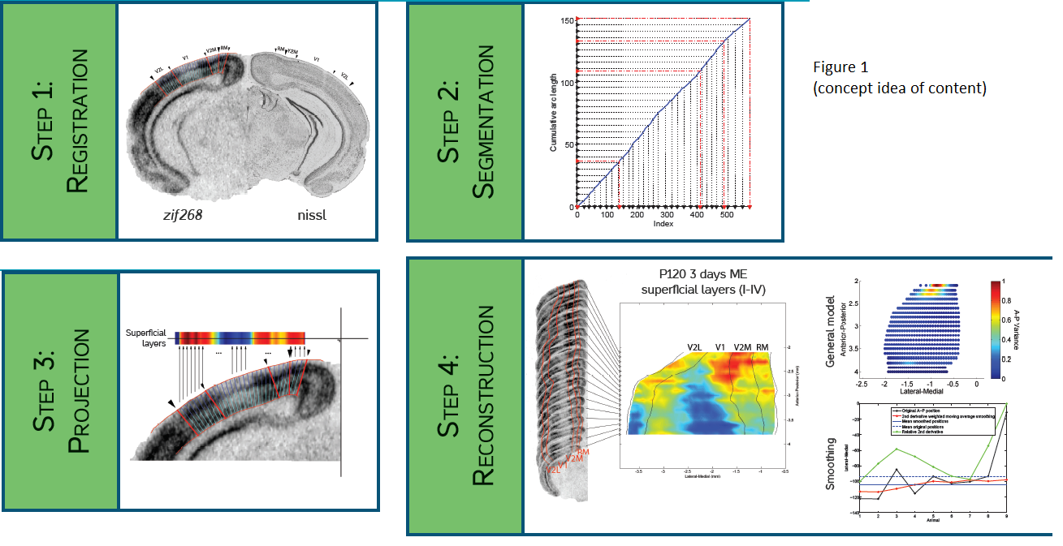

Figure 1: Concept idea about content (copy-paste from EVCM 2015 poster)